🏛 Nested Table with Starbursts

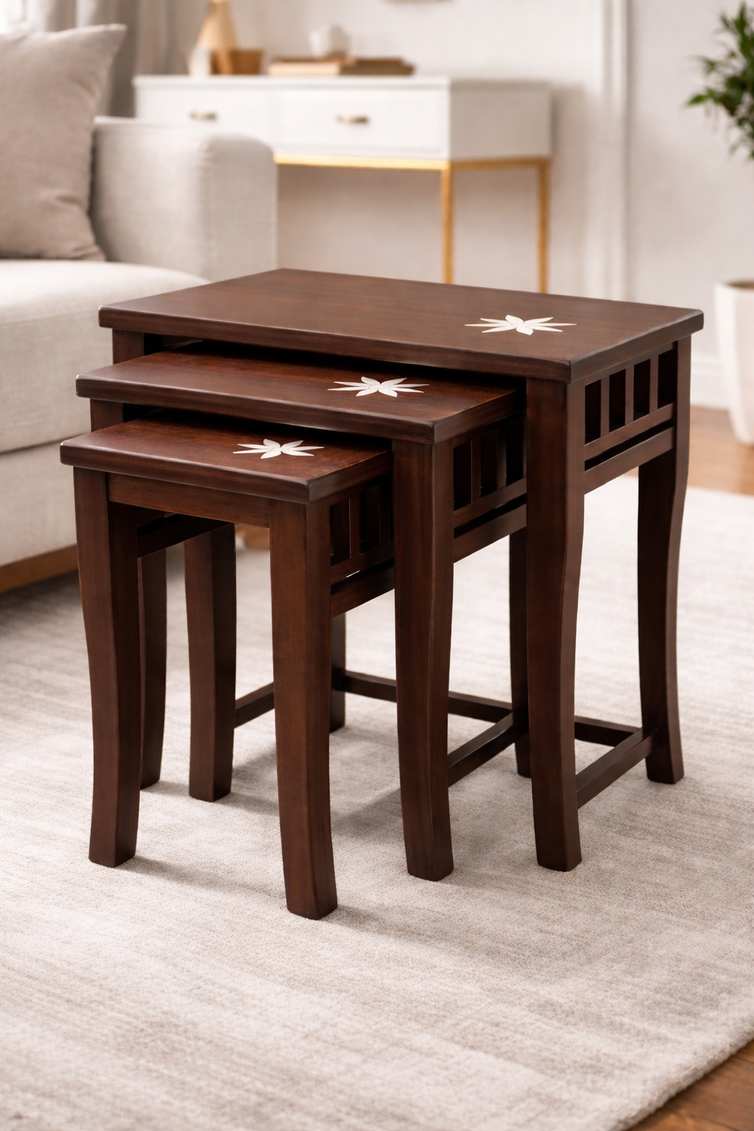

Refined Everyday Luxuryvate your living space with this elegant set of three nesting tables, thoughtfully designed to blend everyday functionality with artistic refinement.
Crafted in a rich walnut finish, each rectangular tabletop features a distinctive starburst inlay — a subtle yet striking design element that adds timeless character and visual sophistication.

Designed to Adapt
This coordinated set of three:
• Tucks neatly into one another to save space
• Slides out effortlessly when extra surface is needed
• Works beautifully as a layered center table
• Functions individually as side tables for décor, serving, or daily essentials
Flexible design. Effortless style.

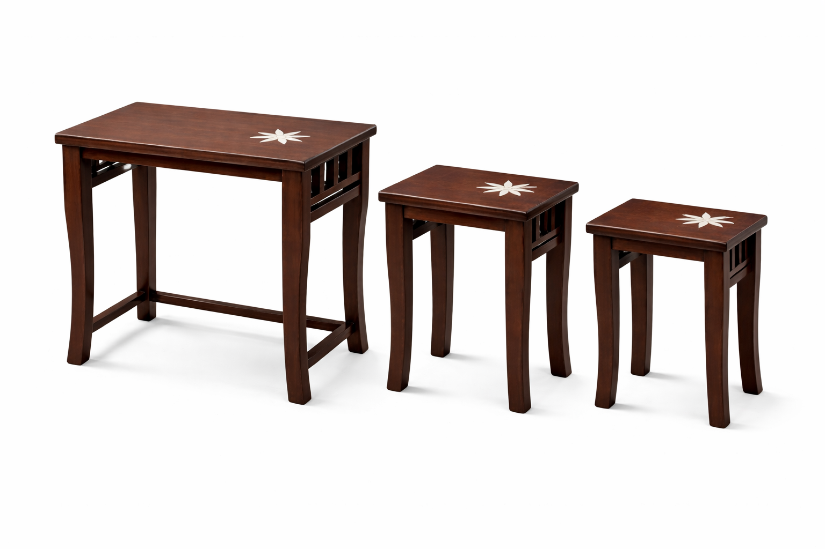

Balanced Craftsmanship
The graceful tapered legs and structured frame provide:
• Visual symmetry
• Strong, stable support
• A clean architectural profile
The warm walnut tone paired with the decorative inlay makes this set ideal for:
• Modern interiors
• Contemporary homes
• Classic living spaces
• Boutique lounge styling

A Statement in Subtlety
Whether placed beside a sofa, styled in a lounge corner, or used as an elegant accent piece, this nested set delivers:
Practicality
Craftsmanship
Understated charm
All in one refined composition.

WOOFURT
Manufactured & Marketed by WooFurt
Contact: 9217577996 | 9217577995

