🏛 NESTED TABLE SET
Smart Design. Timeless Utility

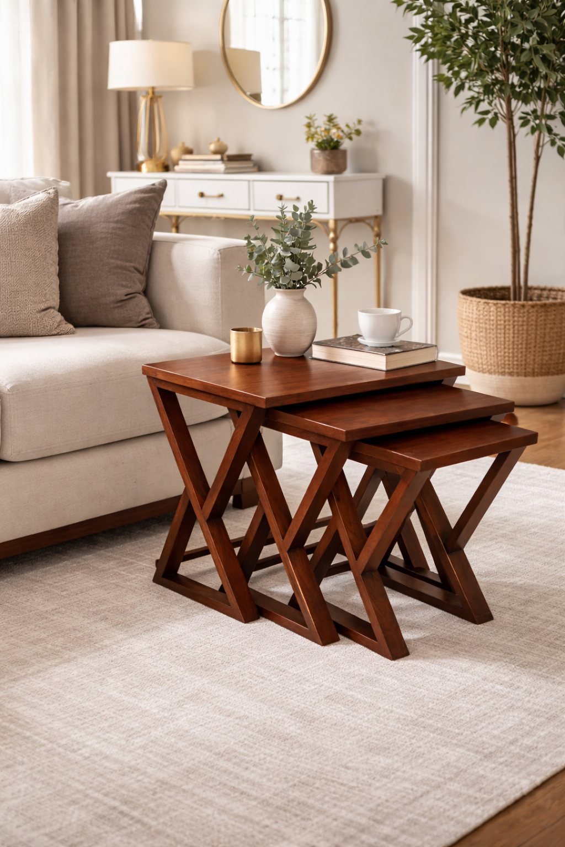

Elegant Everyday Function
Elevate your living space with this thoughtfully designed set of three nesting tables — where practicality meets refined style. Crafted in a rich walnut finish, the clean rectangular tops rest on bold X-shaped legs, adding architectural character while ensuring strong structural stability.
Expand When You Need
Designed as a coordinated set of three, the tables:
• Tuck neatly into one another to save space
• Slide out effortlessly when extra surface area is needed
• Can be separated as side tables for serving, décor, or everyday use
Flexible. Functional. Beautiful
Warm & Versatile
The deep walnut tone and sleek silhouette make this set a perfect fit for:
• Modern interiors
• Classic living rooms
• Lounge corners
• Sofa-side styling
Whether hosting guests or styling décor accents, this nested set brings both practicality and refined charm
Craftsmanship & Finish
Material: Premium Engineered Wood / Solid Wood Frame
Finish: Walnut Polish
Leg Style: X-Shaped Support Design
WOOFURT
Manufactured & Marketed by WooFurt
Contact: 9217577996 | 9217577995

